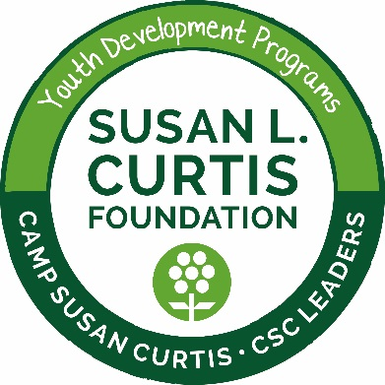
FOR IMMEDIATE RELEASE
Contact: Melissa Cilley, Executive Director
Phone: 207-774-1552
E-mail: mcilley@susancurtisfoundation.org

Camp Susan Curtis to serve 23,000 free meals to Maine youth

PORTLAND, Maine (June 26, 2017) ̶ Nearly 500 economically disadvantaged Maine youth will receive breakfast, lunch, dinner and a snack while at Camp Susan Curtis (CSC) this summer, totalling over 23,000 free meals during the camp’s season. As a USDA Summer Food Service Program, CSC staff are qualified to deliver quality meals, which are served family style to camp participants.

“The free meal program is a critical support for our kids and the Food Service Program helps us use nutritional education to develop the long-term health and well-being of participants,” said Terri Mulks, CSC’s Camp Director. “Food insecurity is present in the lives of all the youth we serve, so providing free meals with this program is one less challenge they have to face daily.”

The youth development programs at Camp Susan Curtis teach life skills and character development to economically disadvantaged Maine youth in a summer camp setting in Stoneham, Maine. Each year the camp serves approximately 500 youth, with every child sponsored through donations. CSC programs receive no state or federal funding beyond USDA reimbursement as a Summer Food Service Program.

“The impact that two weeks, year after year has on these kids is remarkable and the need throughout Maine is so much more than 500 participants,” said Melissa Cilley, Executive Director of the Susan L. Curtis Foundation, which operates Camp Susan Curtis. “We see a bright future for all our youth as well as for our programs: expanding our offerings to more effectively help our current youth break down barriers and access their education, while expanding our reach to serve even more Maine youth. Every program, partnership and dollar of support we receive helps realize that vision.”

All meals are the same for every child regardless of race, color, national origin, sex, age or disability, and there will be no discrimination in the course of the meal service. [If any participant family wishes to file a Civil Rights program complaint of discrimination, call (866) 632-9992 to request a form. You may also write a letter containing all of the information requested in the form emailed to: program.intake@usda.gov or sent to: U.S. Department of Agriculture, Director, Office of Adjudication, 1400 Independence Ave, S.W., Washington, D.C. 20250-9410. Individuals who are deaf, hard of hearing or have speech disabilities may contact USDA at (800) 877- 8339 or (800) 845-6136 (Spanish). USDA is an equal opportunity provider and employer.]

About the Susan L. Curtis Foundation
Since 1974, the programs of the Susan L. Curtis Foundation at Camp Susan Curtis(CSC) have taught critical life skills and character development to over 17,000 economically disadvantaged Maine youth from grades 3 through 12. Referred by their schools all over the state, CSC youth return year after year with opportunities to reconnect and learn all year long through the new CSC Leaders programs. CSC’s award-winning programs are fully sponsored through fundraising and are highly impactful: 99% of long-term, leadership participants graduate from high school and more than 8 out of 10 go on to some form of post-secondary education. CSC’s youth development programs are operated by the Susan L. Curtis Charitable Foundation with administrative offices located in Portland. For more information, please visit http://www.susancurtisfoundation.org/.

###

